WORKING WITH TRIGGERS

EXP NO : 13

DATE : 22.10.2024

NAME : VELAN A

ROLL NO : 230701374

Program 1

Write a code in PL/SQL to develop a trigger that enforces referential integrity by preventing the deletion of a parent record if child records exist.

CREATE OR REPLACE TRIGGER prevent_parent_deletion BEFORE DELETE ON employees

# FOR EACH ROW DECLARE

pl_dept_count NUMBER; BEGIN

# SELECT COUNT(*)

INTO pl_dept_count FROM department

WHERE dept_id = :OLD.employee_id; IF pl_dept_count > 0 THEN

RAISE_APPLICATION_ERROR(-20001, 'Cannot delete employee record as department records exist.');

# END IF; END;

DELETE FROM employees WHERE employee_id = 70;

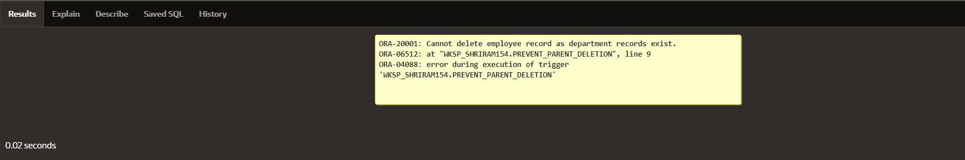

Write a code in PL/SQL to create a trigger that checks for duplicate values in a specific column and raises an exception if found.

CREATE OR REPLACE TRIGGER prevent_duplicate_manager_id BEFORE INSERT OR UPDATE ON employees

# FOR EACH ROW DECLARE

pl_count NUMBER; BEGIN

# SELECT COUNT(*)

INTO pl_count FROM employees

WHERE manager_id = :NEW.manager_id AND employee_id != :NEW.employee_id; IF pl_count > 0 THEN

RAISE_APPLICATION_ERROR(-20003, 'Duplicate manager_id found: ' ||

:NEW.manager_id); END IF;

# END;

INSERT INTO employees (employee_id, first_name, last_name, email, phone_number, hire_date, job_id, salary, commission_pct, manager_id, department_id)

VALUES (202, 'Jane', 'Smith', 'john006@gmail.com',7383922241,'11/9/2000','ST_CLERK',10000,0.15,400,80);

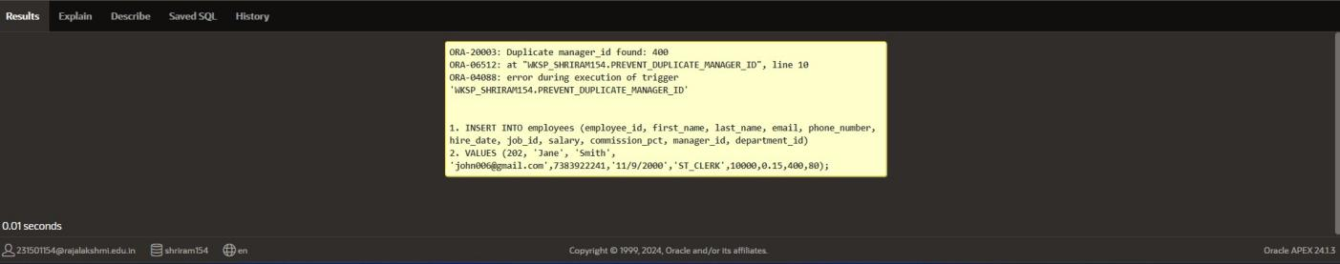

Write a code in PL/SQL to create a trigger that restricts the insertion of new rows if the total of a

column's values exceeds a certain threshold.

CREATE OR REPLACE TRIGGER restrict_salary_insertion BEFORE INSERT ON employees

# FOR EACH ROW DECLARE

total_salary NUMBER; threshold NUMBER := 100000;

# BEGIN

SELECT SUM(salary) INTO total_salary FROM employees;

IF (total_salary + :NEW.salary) > threshold THEN

RAISE_APPLICATION_ERROR(-20004, 'Insertion denied: Total salary exceeds the threshold of ' || threshold);

# END IF; END;

INSERT INTO employees (employee_id, first_name, last_name, email, phone_number, hire_date, job_id, salary, commission_pct, manager_id, department_id)

VALUES (203, 'Charlie', 'Brown', 'charlie203@gmail.com', '9122334455','03/01/2021', '#cb203', 5000, 0.20, 1000, 50);

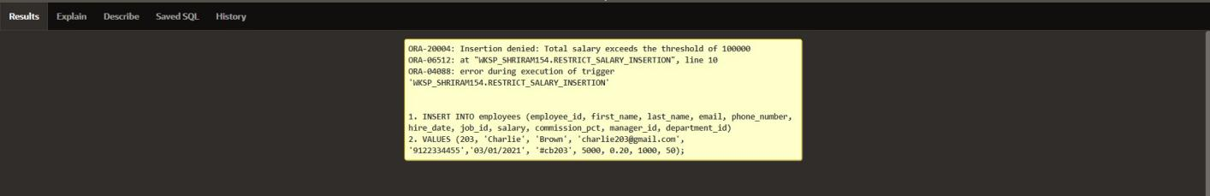

Write a code in PL/SQL to design a trigger that captures changes made to specific columns and logs them in an audit table.

CREATE OR REPLACE TRIGGER audit_changes AFTER UPDATE OF salary, job_id ON employees FOR EACH ROW

# BEGIN

IF :OLD.salary != :NEW.salary OR :OLD.job_id != :NEW.job_id THEN INSERT INTO employee_audit (

employee_id, old_salary, new_salary, old_job_title, new_job_title, change_timestamp, changed_by

# ) VALUES (

:OLD.employee_id,

:OLD.salary,

:NEW.salary,

:OLD.job_id,

:NEW.job_id, SYSTIMESTAMP, USER

# ); END IF;

**END;**

UPDATE employees

SET salary = 55000, job_id = 'ST_CLERK' WHERE employee_id = 176;

SELECT * FROM employee_audit;

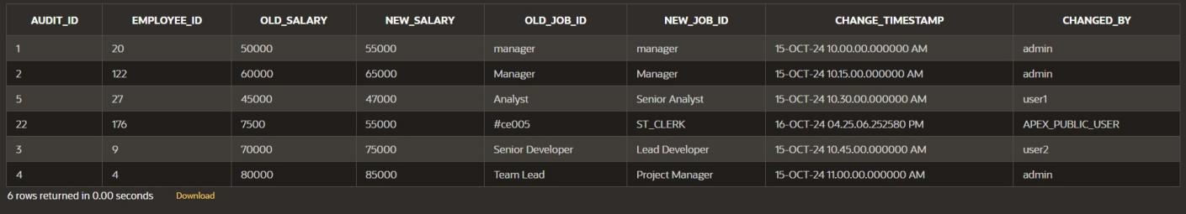

Write a code in PL/SQL to implement a trigger that records user activity (inserts, updates, deletes) in an audit log for a given set of tables.

CREATE OR REPLACE TRIGGER trg_audit_employees AFTER INSERT OR UPDATE OR DELETE ON employees FOR EACH ROW

# DECLARE

v_old_values CLOB; v_new_values CLOB;

# BEGIN

**IF INSERTING THEN**

v_old_values := NULL;

v_new_values := 'employee_id: ' || :NEW.employee_id || ', ' || 'first_name: ' || :NEW.first_name || ', ' ||

'salary: ' || :NEW.salary;

INSERT INTO audit_log (action, table_name, record_id, changed_by, new_values) VALUES ('INSERT', 'employees', :NEW.employee_id, USER, v_new_values);

# ELSIF UPDATING THEN

v_old_values := 'employee_id: ' || :OLD.employee_id || ', ' || 'first_name: ' || :OLD.first_name || ', ' ||

'salary: ' || :OLD.salary;

v_new_values := 'employee_id: ' || :NEW.employee_id || ', ' || 'first_name: ' || :NEW.first_name || ', ' ||

'salary: ' || :NEW.salary;

INSERT INTO audit_log (action, table_name, record_id, changed_by, old_values, new_values)

VALUES ('UPDATE', 'employees', :NEW.employee_id, USER, v_old_values, v_new_values);

# ELSIF DELETING THEN

v_old_values := 'employee_id: ' || :OLD.employee_id || ', ' || 'first_name: ' || :OLD.first_name || ', ' ||

'salary: ' || :OLD.salary; v_new_values := NULL;

INSERT INTO audit_log (action, table_name, record_id, changed_by, old_values) VALUES ('DELETE', 'employees', :OLD.employee_id, USER, v_old_values);

# END IF;

INSERT INTO employees (employee_id, first_name, salary) VALUES (3, 'Ball', 50000);

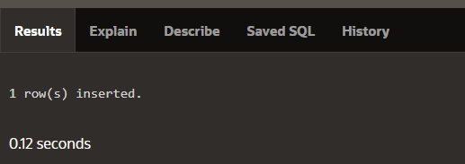

UPDATE employees SET salary = 55000

WHERE employee_id = 3;

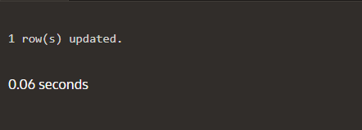

DELETE FROM employees WHERE employee_id = 3;

SELECT * FROM audit_log;

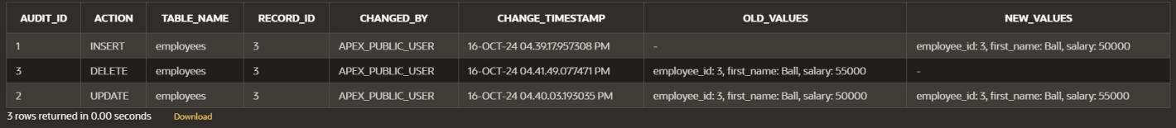

Write a code in PL/SQL to implement a trigger that automatically calculates and updates a running total column for a table whenever new rows are inserted.

CREATE TABLE transactions ( transaction_id NUMBER PRIMARY KEY, amount NUMBER,

running_total NUMBER

**);**

CREATE OR REPLACE TRIGGER update_running_total FOR INSERT ON transactions

# COMPOUND TRIGGER

TYPE amount_array IS TABLE OF NUMBER INDEX BY PLS_INTEGER;

new_amounts amount_array;

# BEFORE EACH ROW IS BEGIN

new_amounts(:NEW.transaction_id) := :NEW.amount; END BEFORE EACH ROW;

# AFTER STATEMENT IS BEGIN

**DECLARE**

v_total NUMBER; BEGIN

SELECT NVL(MAX(running_total), 0) INTO v_total

FROM transactions;

FOR i IN new_amounts.FIRST .. new_amounts.LAST LOOP v_total := v_total + new_amounts(i);

UPDATE transactions

SET running_total = v_total WHERE transaction_id = i;

# END LOOP; END;

**END AFTER STATEMENT;**

END update_running_total;

INSERT INTO transactions (transaction_id, amount) VALUES (1, 10000);

INSERT INTO transactions (transaction_id, amount) VALUES (2, 20000);

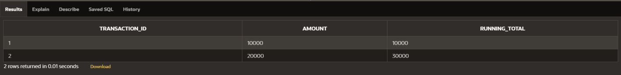

Program 7

Write a code in PL/SQL to create a trigger that validates the availability of items before allowing an order to be placed, considering stock levels and pending orders.

CREATE TABLE inventory ( item_id NUMBER PRIMARY KEY,

item_name VARCHAR2(100), stock_level NUMBER

**);**

CREATE TABLE orders (

order_id NUMBER PRIMARY KEY, item_id NUMBER,

quantity NUMBER, order_status VARCHAR2(20),

CONSTRAINT fk_item FOREIGN KEY (item_id) REFERENCES inventory(item_id)

**);**

CREATE OR REPLACE TRIGGER validate_stock_before_order BEFORE INSERT ON orders

# FOR EACH ROW DECLARE

v_stock_level NUMBER; v_pending_orders NUMBER;

# BEGIN

SELECT stock_level INTO v_stock_level FROM inventory

WHERE item_id = :NEW.item_id; SELECT NVL(SUM(quantity), 0) INTO v_pending_orders

FROM orders

WHERE item_id = :NEW.item_id AND order_status = 'Pending';

IF (:NEW.quantity + v_pending_orders) > v_stock_level THEN RAISE_APPLICATION_ERROR(-20001, 'Insufficient stock for item: ' || :NEW.item_id);

# END IF; END;

INSERT INTO orders (order_id, item_id, quantity, order_status) VALUES (1, 101, 5, 'Pending');

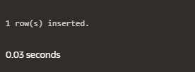

INSERT INTO orders (order_id, item_id, quantity, order_status) VALUES (2, 103, 20, 'Pending');

